OBJECTIVES

General
The study’s primary objective is to develop a low-cost, threshold-based adaptive failover routing system that integrates a MANET of local IoT/mobile devices with a LEO-satellite path to maintain emergency communications during terrestrial wireless infrastructure failure.

Specific
This section lists the specific objectives to be achieved through the design and development of the project

Hardware
This section lists the specific objectives to be achieved through the design and development of hardware components for the project.
- MANET Node
  - Objective: Design a low-cost MANET node capable of establishing peer-to-peer wireless connectivity for emergency communication.
  - Hardware Parameters:
 Microcontroller / SBC: ESP32 or Raspberry Pi
Wireless Interface: Wi-Fi 802.11 b/g/n or LoRa, 2.4 GHz Battery: 3.7V Li-ion, capacity 2000–5000 mAh
Antenna: Omnidirectional, 2.4 GHz
  - Expected Outcome: Each node can autonomously connect to neighbouring nodes to form a MANET with minimal setup.
- Gateway Device
  - Objective: Develop a gateway capable of bridging MANET networks and a LEO-satellite backhaul for adaptive failover.
  - Hardware Parameters:
Microcontroller / SBC: Raspberry Pi 4 or equivalent Communication Interfaces:
Terrestrial: Wi-Fi or Ethernet for MANET integration Satellite: USB or Ethernet interface to LEO satellite terminal

Power Supply: 5V/3A DC via adapter or battery pack
  - Expected Outcome: Gateway autonomously switches between terrestrial MANET and satellite backhaul depending on link quality.

- Integrated Sensor and Monitoring Module
  - Objective: Provide real-time metrics for intelligent routing decisions.
  - Hardware Parameters / Metrics:
RSSI: Measured in dBm, threshold configurable (e.g., –78 dBm) SNR: Measured in dB
Hop Count: Number of nodes traversed per route Battery Level: Measured in percentage (%)
Gateway & Satellite Status: Online/offline detection
  - Expected Outcome: System continuously monitors network quality, allowing software to make autonomous routing and failover decisions.

Software
To develop:

- Adaptive Routing and Decision Logic
  - Implement a lightweight routing protocol, specifically AODV (Ad hoc On-Demand Distance Vector) with metric weighting based on RSSI, SNR, hop count, and battery level, to determine optimal routes for emergency communication.
  - Integrate automatic failover logic that triggers satellite backhaul routing when terrestrial MANET link quality drops below predefined thresholds (e.g., RSSI < – 78 dBm for 10 seconds).
  - Ensure delay-tolerant behaviour by buffering messages during satellite latency, mitigating packet loss, and preserving message order.
- Reliable Messaging Protocol
  - Develop a messaging protocol that guarantees high packet delivery reliability
(≥90%) under both normal MANET operation and during satellite failover.

  - Include mechanisms to handle high-latency satellite links (expected 500–700 ms), ensuring messages are queued and retransmitted as necessary without human intervention.
- Intelligent Link Monitoring and Decision Support
  - Continuously monitor real-time link metrics such as RSSI, SNR, hop count, battery levels, gateway proximity, and satellite link status.
  - Make autonomous routing decisions based on these metrics, ensuring minimal communication disruption during network degradation or outages.

VALIDATION
The proposed study will be verified in terms of the following criteria:
- Efficacy

  - Objective: Ensure the routing system detects terrestrial network degradation and activates satellite failover autonomously.
  - Validation Metric: Failover is triggered when the Received Signal Strength Indicator (RSSI) drops below –78 dBm for at least 10 seconds.
  - Test Scenario: Simulate link degradation in MANET nodes by gradually reducing signal strength below threshold. Observe if the system activates satellite routing automatically.
  - Expected Outcome: Satellite failover occurs without human intervention, and normal MANET routing resumes once the link improves above threshold.
- Efficiency

  - Objective: Maintain high message delivery reliability during failover scenarios.
  - Verification Metrics:
    - Packet Delivery Rate (PDR) ≥ 90% during failover.
    - End-to-end latency within 500–700 ms for satellite links.
    - Failover time ≤ 5 seconds from threshold detection to route switching.
  - Test Scenario: Conduct message transmission under simulated terrestrial network failure. Measure PDR, latency, and failover time.

  - Expected Outcome: The system demonstrates communication reliability compared to a non-adaptive routing system.

System Uptime

  - Objective: Ensure continuous MANET connectivity and route monitoring during the entire testing period.
  - Verification Metrics:
    - System uptime ≥ 80% over a 24-hour continuous test.
    - Continuous monitoring of link metrics with automatic route adjustment when thresholds are exceeded.
  - Test Scenario: Maintain MANET operation under normal and degraded network conditions for 24 hours, including simulated link interruptions.
  - Expected Outcome: The system reliably maintains emergency communication without downtime.

Criteria | Verification Metric | Target Threshold | Sample Test Result | Status
Efficacy | RSSI Trigger | <-85 dBm for ≥  10 seconds | -88 dBm for 12 seconds | Pass
Efficiency | Packet Delivery Rate | ≥90% | 94% | Pass
Efficiency | End-to-End Latency | 500-700 ms | 615 ms | Pass
Efficiency | Failover Time | 5 seconds | 3.5 seconds | Pass
Reliability | System uptime | ≥99% over 24  hours | 99.3% | Pass
Verification Results Table Example

SCOPE AND DELIMITATION
This study aims to focus on the following:

- Development of a prototype user terminal capable of forming peer-to-peer MANET links and automatically switching to a LEO satellite–based backhaul during link degradation or outage conditions.
- Implementation of link-quality monitoring and adaptive routing mechanisms using parameters such as RSSI, SNR, hop count, node battery level, gateway or satellite availability, and satellite link status to determine when failover should occur.
- Performance evaluation such as RSSI, SNR, latency, connectivity stability, packet-delivery success rate, failover switching time, and overall system uptime.
- The Use of MATLAB and Arduino IDE for signal modeling, algorithm simulation, embedded programming, and prototype control and monitoring.
- Design of dual-interface communication hardware consisting of a MANET-enabled node using commodity wireless components and a gateway module capable of connecting to a LEO satellite terminal during failover operation.
- Development of lightweight control logic and firmware that autonomously detects terrestrial link failure and initiates satellite failover without requiring human intervention.
This study is delimited by the following:

- Indoor, static-node testing only, wherein all testing and performance evaluation are confined to indoor environments within selected buildings of Adamson University using static nodes, excluding outdoor field tests, long-range propagation studies, multi-building setups, and node mobility.
- Single satellite service path usage, where only one available LEO satellite link is utilized for backhaul evaluation, excluding multi-satellite, multi-orbit, or commercial-grade satellite switching.

- Limited environmental considerations, as external factors such as weather effects, outdoor radio propagation, real orbital movement impacts, major interference sources, and large-scale disaster scenarios are not simulated or included.
- Limited deployment scale, such that the study does not evaluate large-area network coverage or wide-scale emergency deployments and is restricted to localized indoor testing environments.
- Emergency communication focus only, limiting the system to low-bandwidth emergency messaging and excluding high-throughput, multimedia, or broadband communication services.
- Academic research purpose, wherein the system is developed solely as a proof-of-concept for research and educational use and is not intended for commercial deployment or regulatory certification.
- Security exclusions, as cybersecurity mechanisms such as encryption, authentication, intrusion detection, and other security-related functions are beyond the scope of this study.

SYSTEM FLOW DIAGRAM

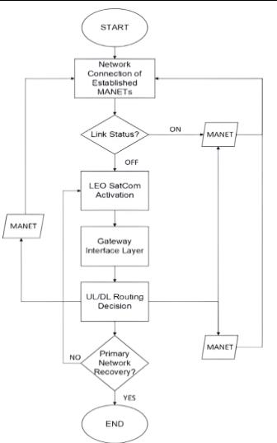

3.5.1 Concept of Operation
This subsection describes how the system behaves during normal operation and emergency conditions. It explains the transition from terrestrial connectivity to MANET and satellite-based communication through adaptive failover.
Once a terrestrial network failure (specifically cellular base stations or local access points) or outage is detected to every mobile device in scope such as loss of access point connectivity, power interruption, or sustained degradation below predefined thresholds the system automatically transitions into emergency mode. Upon activation of this mode, the gateway initializes the LEO satellite link to establish a non-terrestrial backhaul connection once a 3 out of 4 MANET device link outage or signal degradation is achieved. Simultaneously, MANET prototype modules that

were previously on standby are activated, enabling nearby nodes to automatically discover one another and form a self-organizing, multi-hop peer-to-peer network.
Within the MANET, each node operates as both a communication endpoint and a router, relaying lightweight data such as text messages and compressed voice packets across multiple hops toward the portable gateway. An adaptive routing and failover algorithm dynamically selects the optimal path based on link quality, hop count, battery level, and proximity to the gateway, prioritizing reliability and energy efficiency for low-data-rate transmission. Upon reaching the gateway, the aggregated data is forwarded through the LEO satellite link, enabling resilient text and voice communication even in the absence of terrestrial network infrastructure.

Throughout emergency operation, the system continuously monitors network conditions and dynamically updates routing decisions to maintain reliability and minimize disruption. When terrestrial connectivity is restored and link quality returns to acceptable levels, the system autonomously reverts to normal operation, deactivating the MANET and satellite links and resuming standby mode. This autonomous transition ensures resilient, low-cost, and uninterrupted emergency communication without requiring human intervention.

3.5.2.2 Test Campaign
This subsection presents the testing strategy used to evaluate the performance of the proposed system. It outlines the scenarios, parameters, and metrics used to validate reliability, latency, and failover effectiveness.

A structured test campaign will be conducted to evaluate the performance of the adaptive failover routing system following the Threshold for Link Quality distance parameters validating reliability, latency, and overall effectiveness in emergency scenarios

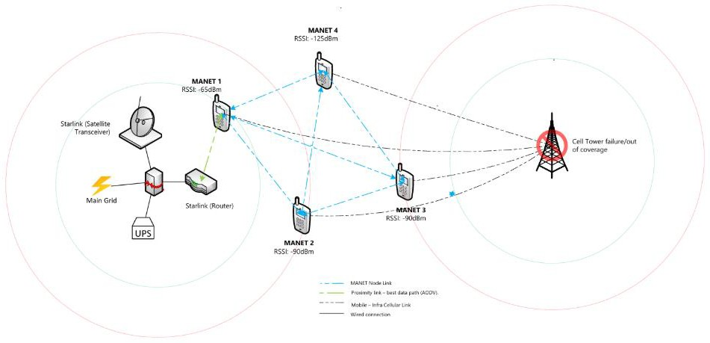
Figure 3.2 Test campaign workflow for adaptive routing evaluation
Figure 3.2 illustrates the test campaign workflow used to evaluate the performance of the proposed adaptive failover routing system under controlled emergency scenarios. The figure presents multiple locations of MANET within the area of coverage of a wireless infrastructure. Each location within or beyond 150-200 ft of coverage corresponds to a specific RSSI reading that will determine the failover process. The figure presents the sequence of testing stages, beginning with normal MANET operation, followed by intentional degradation of terrestrial link quality to simulate network failure conditions. During this phase, key parameters such as RSSI, SNR, packet delivery ratio, latency, and failover switching time are continuously monitored.

SYSTEM COMPONENTS

Main Grid. The primary electrical power source supplies energy to the terrestrial gateway and associated networking equipment under normal operating conditions. During the test campaign, power interruption scenarios are simulated to evaluate system behavior under emergency conditions and to validate failover reliability.

UPS (Uninterruptible Power Supply). The UPS provides short-term backup power to the gateway during sudden power outages. Its role in the test campaign is to ensure graceful system

operation and prevent immediate shutdown, allowing sufficient time for failover routing mechanisms to activate and stabilize.

Gateway. The gateway serves as the core network control node, responsible for managing routing decisions, monitoring link quality parameters, and interfacing between terrestrial MANET links and the satellite backhaul. During testing, the gateway continuously evaluates RSSI, SNR, packet delivery ratio, latency, and failover switching time to determine whether a link remains within acceptable operational thresholds.

LEO Satellite Terminal. The LEO satellite terminal provides an alternative backhaul communication path when terrestrial MANET links degrade beyond the failover threshold. In the test campaign, this component is activated once the failover RSSI threshold (−78 dBm) is reached or when terrestrial links become unavailable, ensuring communication continuity in emergency scenarios.

Router. The router acts as the traffic distribution and aggregation point between the gateway and MANET nodes. It dynamically redirects data flows based on routing decisions issued by the gateway. During testing, the router demonstrates adaptive behavior by rerouting traffic from degraded terrestrial links to the satellite backhaul when thresholds are exceeded.
Inner Orange Circle – Warning Threshold. The inner orange circle defines the warning threshold boundary, corresponding to an RSSI of −62 dBm. When a MANET node enters this region, the system flags link degradation and intensifies monitoring of SNR, latency, and packet delivery ratio, but terrestrial routing is still maintained.

Outer Circle – Failover Threshold. The outer circle defines the failover threshold boundary, corresponding to an RSSI of −78 dBm. Beyond this boundary, terrestrial link quality is considered unreliable, and automatic failover to the satellite link is initiated to preserve network availability.

Link Degradation Region (Beyond 200 ft). Distances beyond 200 ft represent strong signal degradation, where RSSI values fall below −78 dBm and SNR drops below acceptable levels.

This region is critical for validating the responsiveness and effectiveness of the adaptive failover routing system under worst-case emergency conditions.
Below are the Test Campaign (TC) scenarios where every component will be laid with variable conditions to determine the mode of operation of the overall system. Each one of it will comprise of the test setup, procedure, parameters to be measured, and the acceptance criteria for the operation to be executed once the criteria is met by the scenario.

TC-01: BASELINE OPERATION (NORMAL TERRESTRIAL CONNECTIVITY)

Test Setup

The test environment consists of 4 MANET nodes implemented using LoRa/ESP32 modules for short-long range transmission of either text or voice message each powered by a Li-ion battery with a minimum charge level of 70%. A gateway device is connected to a functioning terrestrial network via Wi-Fi or Ethernet, while the LEO satellite link remains available but inactive in standby mode. Node placement is configured such that inter-node signal strength is stable, with RSSI values maintained at or above –78 dBm but not beyond –120 dBm to represent normal operating conditions.

Procedure

- Power on MANET nodes and gateway.
- Allow nodes to auto-discover and form a MANET link.
- Transmit periodic text packets between notes for system link availability checkup.
- Have a link monitoring with all 4 nodes to check for system link availability once each node is activated.

Measured Parameters

RSSI, SNR, hop count, packet delivery rate, and end-to-end latency are recorded throughout the test duration.

Acceptance Criteria

- Packet delivery rate remains at or above 95 percent;
- The satellite backhaul must remain inactive for the duration of the test.
- Successful operation is confirmed if the MANET forms autonomously within 30 seconds of system startup.

TC-02: NETWORK DEGRADATION DETECTION

Test Setup
The system configuration remains identical to the baseline operation test. Controlled signal degradation is introduced either by increasing the physical distance between nodes above or below 150ft and 200ft or by applying adjustable RF attenuation to gradually reduce received signal strength.

Procedure

- Signal quality between MANET nodes is progressively degraded until the RSSI falls below
–78 dBm (maintained continuously for 10 seconds).
- System logs and routing behavior are observed.

Measured Parameters
RSSI trends over time, degradation detection time, routing path.

Acceptance Criteria

- RSSI indicators must appear above –78dBm to simulate accurate signal degradation.
- Total loss of signal from cellular infrastructure or access points will serve as a failover trigger

TC-03: FAILOVER ACTIVATION TO SATELLITE BACKHAUL

Test Setup
The MANET remains operational while the gateway device is connected to a LEO satellite terminal. The terrestrial primary connection is intentionally disabled or degraded to ensure to ensure failover trigger thus activating the LEO satellite backhaul.

Procedure

- MANET nodes confirm “terrestrial connectivity failure” transitioning to emergency
communication mode.
- Node in close proximity to the LEO satellite range will serve as the lifeline where all MANET inter-nodal communication will be relayed to.
- LEO-MANET link configuration will be established.

Measured Parameters

Failover trigger time, node disconnection, gateway backhaul status.

Acceptance Criteria

- 4/4 MANET nodes must have the disconnection status in order to activate LEO-Satellite backhaul.
- Failover trigger time will be set to 10 seconds for redundancy

TC-04: SUSTAINED EMERGENCY OPERATION (UPTIME TEST)

Test Setup

The full system is deployed using battery-powered MANET nodes and an operational gateway. Controlled degradation events are periodically introduced to simulate realistic emergency conditions.

Procedure
The system operates continuously for a 24-hour period, transitioning between normal operation, degraded MANET conditions, and satellite failover states. System logs are collected to track health status, routing behavior, and power levels.

Measured Parameters

System uptime, battery levels, routing stability, and continuity of metric monitoring are recorded throughout the test.

Acceptance Criteria
Successful operation is demonstrated if the system maintains an uptime of at least 80 percent over the 24-hour test period. Link metrics must be continuously monitored, adaptive routing must remain operational, and no system crashes, deadlocks, or unrecoverable failures may occur.

TC-05: Recovery and Reversion to Terrestrial Network

Test Setup

The system begins in an active satellite-routing state. Terrestrial connectivity is restored such that RSSI values rise to at least –78 dBm and remain stable.

Procedure
Terrestrial network access is reintroduced and maintained above the acceptable RSSI

threshold for a continuous 10-second interval. System behavior is observed to determine how routing transitions back to terrestrial operation.

Measured Parameters

Recovery detection time, route switching time, and packet loss during the recovery phase are measured.

Acceptance Criteria

The test is considered successful if the system autonomously reverts to terrestrial routing, deactivates the satellite backhaul, and completes route switching within 5 seconds. No message loss is permitted during the recovery process.

